Social Media Tools: COVID Member Communication for Iowa Credit Unions
Safety & Soundness:
- Sample text to accompany image: “Especially in times like this, credit unions are a safe place to keep and protect your money. Deposits are federally-insured by the NCUA up to $250,000. Learn more at https://www.ncua.gov/newsroom/press-release/2020/deposits-are-safe-federally-insured-credit-unions.”
Image w/ general logo to use

Image w/o logo (CU can add their own)

Open to Help:
- Sample text to accompany image: “Iowa credit unions are here for you and open for business. Some credit unions have adjusted hours and lobby logistics, but many offer online options. Your money is safe and sound in your credit union because it is federally-insured by the NCUA. Reach out to your credit union today to learn about services to help you or your small business get through the COVID pandemic.”
Image w/ general logo to use

Image w/o logo (CU can add their own)

NCUA Share Insurance Estimator
- Sample text to accompany image: “All deposits at federally-insured credit unions are protected by the National Credit Union Share Insurance Fund, with deposits insured up to $250,000 per individual depositor. Calculate the amount of your insured funds at your credit union by using the NCUA’s Share Insurance Estimator here: https://www.mycreditunion.gov/insurance-estimator.”
Image w/ general logo to use

Image w/o logo (CU can add their own)

We Are Credit Unions
- Sample text to accompany image: “History has shown that Iowa credit unions are always there for members in times of need and have stepped up to do the right thing. Iowa credit union leaders are your neighbors and committed to helping out your community.”
Image w/ general logo to use

Image w/o logo (CU can add their own)

COVID-19 Scams
- Sample text to accompany image: “Please remain cautious when handling emails and scams related to COVID-19. Scam emails will include attachments or links to fraudulent websites to trick members into revealing sensitive information or donating to fraudulent charities or causes. Visit the NCUA’s Fraud Prevention Center for more information about frauds and scams, including how to report a scam at https://www.mycreditunion.gov/fraud-prevention-center”

Image w/ general logo to use
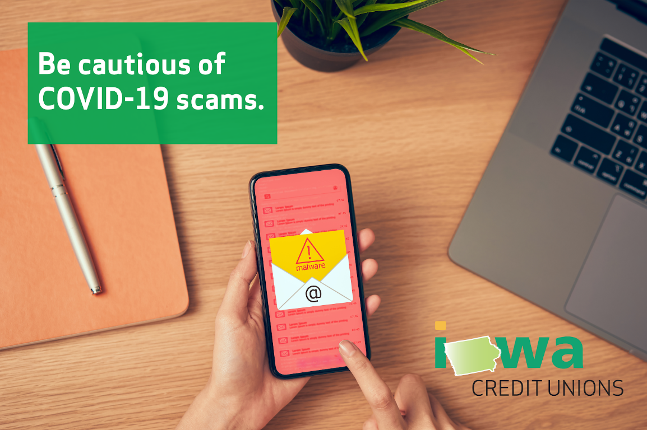

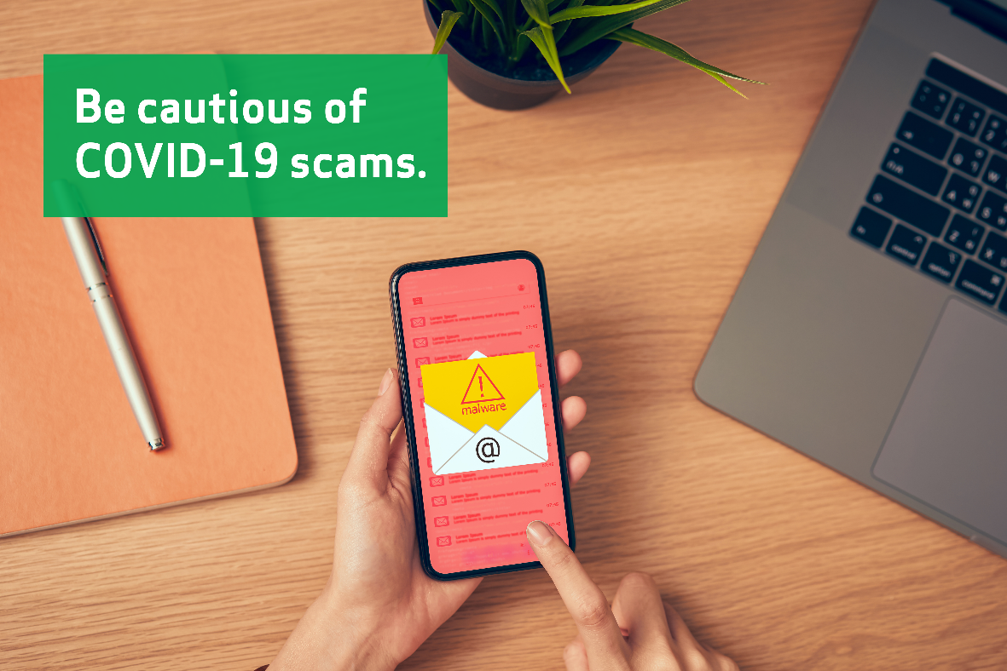
Image w/o logo (CU can add their own)

